**Social Survey Restore & Backup Procedures**

**Current back up procedure:**

1. MySQL – MySQL backup is automatically handled by RDS. RDS takes snapshot of MySQL data daily at 4:47 PM UTC as shown below:

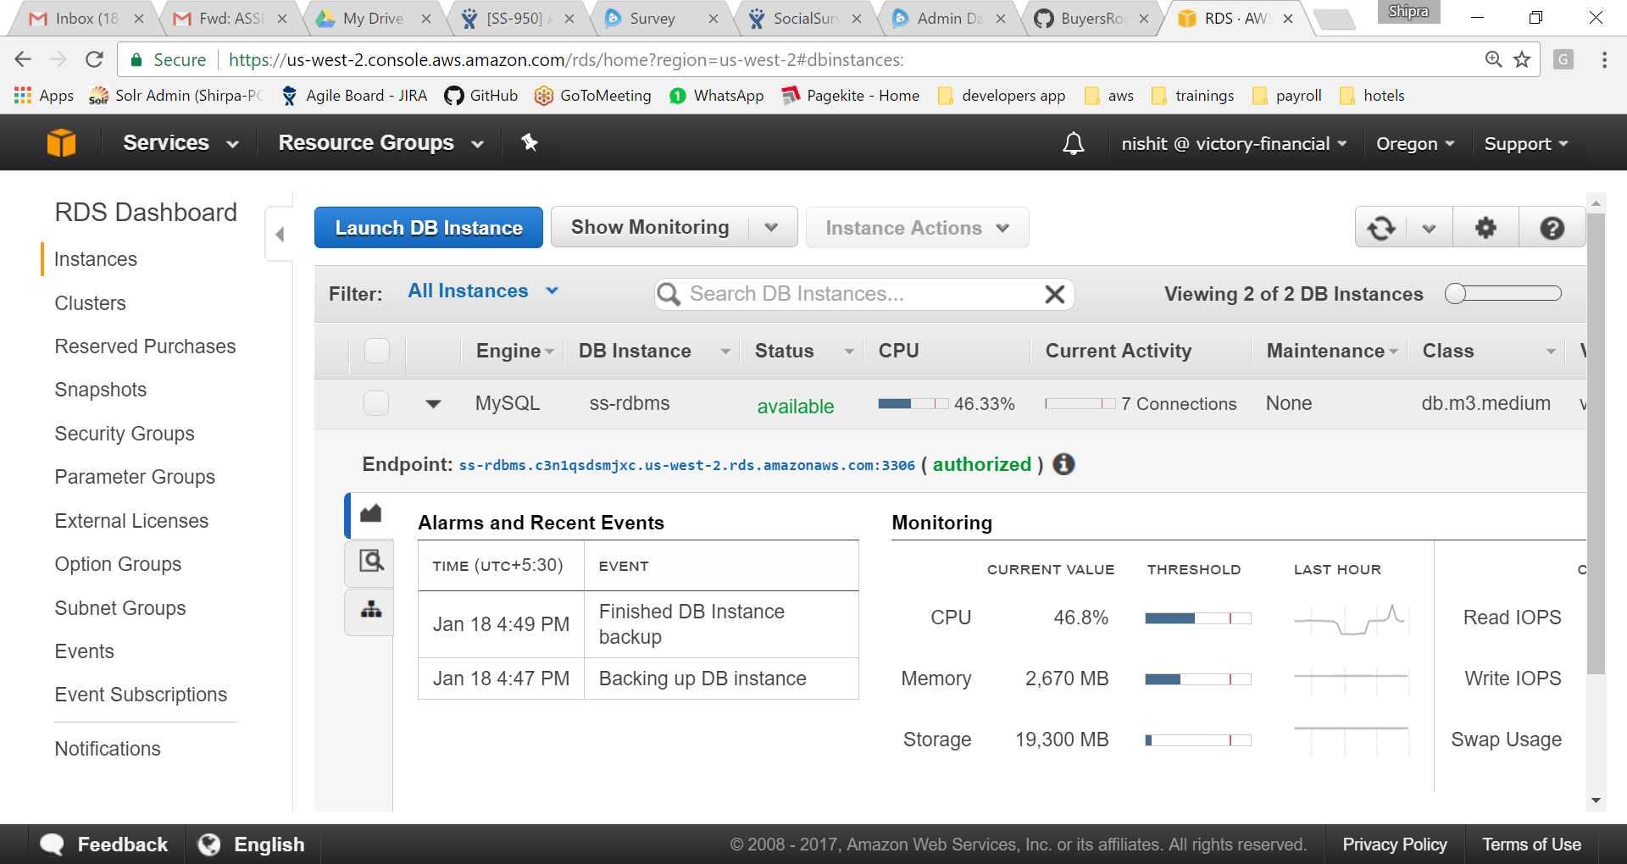

Data can be restored in new RDS instance using below snapshots. Select the latest snapshot and click on Restore Snapshot.

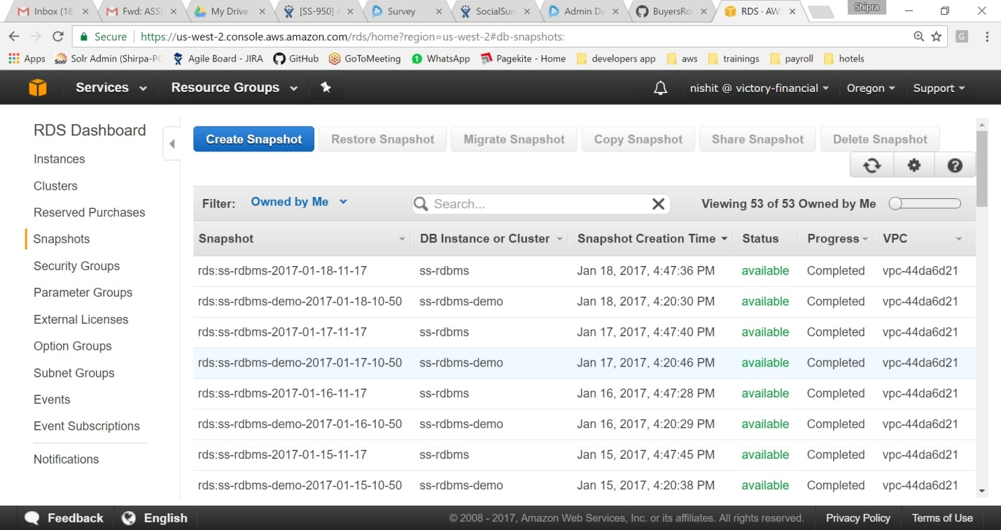

1. Mongo – Mongo data backup is stored in nosql-survey-secondary ec2 instance. Currently only one copy is being stored. Data can be restored by pointing the mongo db path to this back up file.
2. Solr – No back up as of now.
3. SSWeb, SSApi, SSCore – Wars and jars backups are stored in web-survey ec2 instance. Before every deployment, we manually take the backup of wars and jars.

**Proposed backup and restore procedure:**

1. MySql – No need to update the current procedure.
2. Mongo – Mongo itself provides some backup procedure. Need to explore more. Refer below link.

<https://docs.mongodb.com/manual/tutorial/backup-and-restore-tools/>

<https://docs.mongodb.com/manual/tutorial/backup-with-filesystem-snapshots/>

Multiple Mongo data backup files can be sent to S3 bucket using shell script. Refer below link.

<http://three99.com/blog/database-backup-on-s3/>

By setting rules on s3 bucket, data can be moved from S3 to Glacier periodically to keep memory clean. Refer below link to get storage space in glacier.

<https://us-west-2.console.aws.amazon.com/glacier/home?region=us-west-2#/initial-start>

1. Solr – Solr itself provides backup and restore procedure. Need to explore more. Refer below link.

<https://cwiki.apache.org/confluence/display/solr/Making+and+Restoring+Backups>

Solr backups can also be stored in glacier similar to mongo data as explained above.

1. SSApi, SSWeb, SSCore – We take backup of wars and jars before every deployment via a script which will send the backup wars and jar to s3 and then from s3 to glaciers similar to mongo data as explained above.